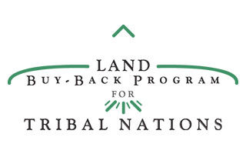
Landowners that are Whereabouts Unknown (WAU) at the
Reservation Name Reservation

Below is a list of landowners who own land at the Reservation Name Reservation and whose whereabouts are unknown as of Date Data of Data Pull. If your name appears on this list, please call the Trust Beneficiary Call Center (TBCC) at 1-888-678-6836 or email TBCCmail@btfa.gov to update your Individual Indian Monies (IIM) account information. If you see someone you know on this list, please tell them to contact the TBCC.

First Name | Last Name

