Statement of Murray Hitzman
Associate Director – Energy and Minerals, U.S. Geological Survey
U.S. Department of the Interior
before the
Senate Energy and Natural Resources Committee
on
March 28, 2017

Good morning Chairman Murkowski, Ranking Member Cantwell, and Members of the Committee, and thank you for the opportunity to discuss the Nation’s foreign mineral dependence.

Background

The U.S. Geological Survey (USGS) is responsible for conducting research and collecting data on a wide variety of mineral resources. Research is conducted to understand the geologic processes that have concentrated known mineral resources at specific localities in the Earth’s crust and to assess quantities, qualities, and areas of undiscovered mineral resources, or potential future supply. USGS mineral commodity specialists collect, analyze, and disseminate data and information that document current production and consumption for 84 mineral commodities, both domestically and internationally for 180 countries. These data include information on domestic production and use, import sources, world production capacity, and recycling. The data allow for a comprehensive understanding of the complete life cycle of mineral resources and materials. These mineral data are published annually in the Mineral Commodities Summaries. The most recent installment for 2017 was released in January.

Global demand for mineral commodities continues to be on the rise. Mineral commodities have ever more applications in consumer and national security products especially those involving advanced technologies. The United States remains a major mineral producer with an estimated total value of non-fuel mineral resources of $75.6 billion and is net exporter of 16 non-fuel mineral commodities. However the country also is increasingly reliant on foreign sources for raw processed mineral materials. In 2016, imports made up more than one-half of the U.S. apparent consumption of 50 non-fuel mineral commodities (valued at $32.3 billion), and the United States was 100% import reliant for 20 of these mineral commodities (valued at $1.3 billion), including 8 identified as critical minerals. This is an increase from 47 non-fuel mineral commodities on which the country was more than one-half dependent in 2015 and 19 non-fuel commodities for which the country was 100% reliant in 2015. China, followed by Canada, supplied the largest number of non-fuel mineral commodities to the U.S. in 2016, similar to the case in 2015.

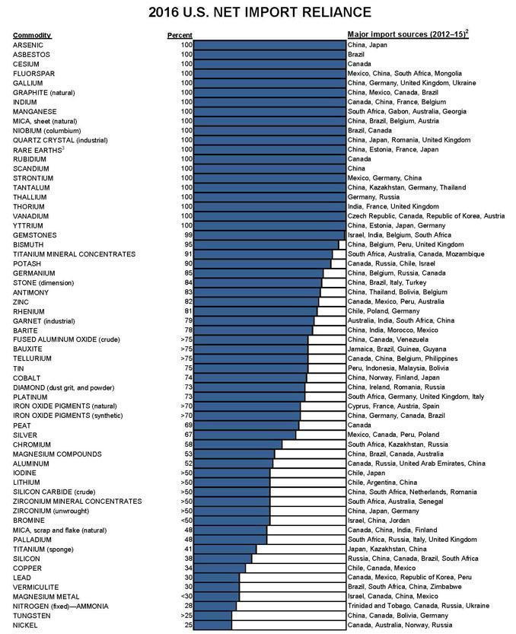

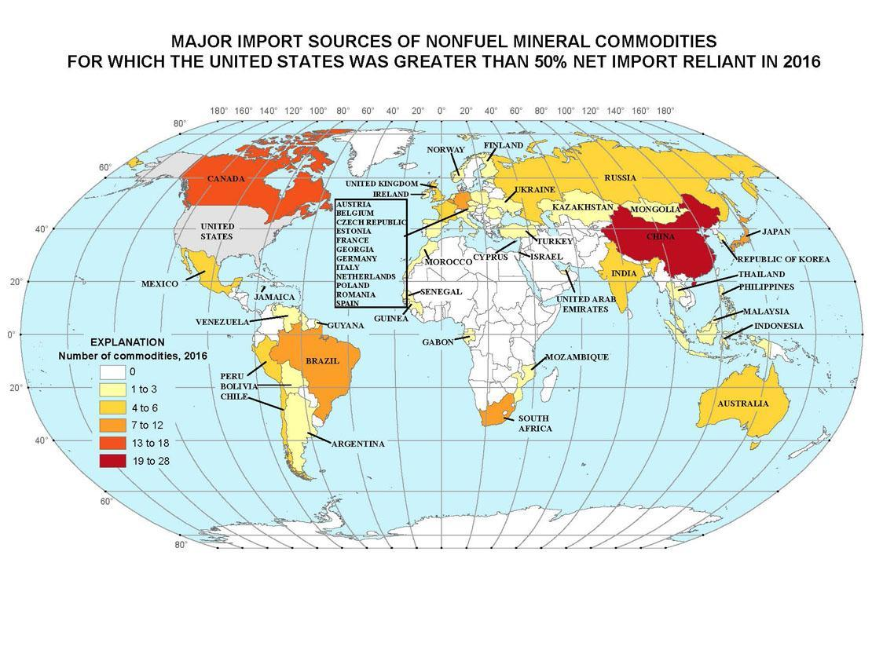
The list of non-fuel mineral commodities for which the United States is 100% import reliant includes some well-known commodities such as manganese and rare earth elements as well as some more obscure commodities such as gallium and niobium. The rare earth elements are currently produced almost exclusively in China though domestic sources do exist, including the recently reopened and then shuttered Mountain Pass, California mine.

The USGS continues to research the occurrence of rare earth element deposits in the United States (a 2010 USGS study documented 28 rare earth deposits in the United States that potentially could be developed) and explore geological processes that may form domestic deposits that are yet to be discovered. For example, USGS scientists are conducting research in the southeastern United States on granites that contain high concentrations of rare earth elements to understand and assess likely chemical and physical processes that could lead to the enrichment and retention of rare earth elements in soil and to characterize the minerals in which heavy rare earth elements reside in regolith. The project will develop criteria and methodologies to delineate the occurrence of rare earth element-clay resources and define characteristics that relate to sustainable mining of rare earth element clay deposits. In addition, the USGS recently released a study on critical minerals, including rare earth elements, in Alaska.

The element gallium is recovered as a byproduct of processing bauxite (the material from which aluminum is extracted) and zinc ores primarily in China (80% of worldwide low-grade gallium capacity). Gallium is used primarily to manufacture gallium-arsenide wafers used in integrated circuits for defense applications and high-performance computers, light emitting diodes (LEDs), and solar cells.

Other exotic elements that the U.S. depends on from foreign sources include europium, which is essential for getting a bright red color out of TV screens and metal oxides responsible for some popular automobile paint colors. As an example of the effect of supply disruptions, after the 2011 Japanese earthquake and tsunami, for several months American vehicle manufacturers were unable to supply customers with popular red and black sports cars and trucks due to the unavailability of a critical ingredient.

In 2015, mineral specialists in the USGS National Minerals Information Center, with cooperation from the Department of Energy, developed an early warning screening tool to identify critical minerals of concern for economic and national security and stay ahead of the curve as technology changes and geopolitical unrest shifts. The tool accounts for several variables in identifying critical minerals, including how vulnerable the supply chain is to disruption, how much production growth is expected for the material, and market dynamics. Once the system has filtered out minerals that are not “potentially critical,” the remaining minerals receive further analysis. In-depth studies allow users to rank each mineral from lower to higher potential criticality. The resultant rankings are currently used by the Defense Logistics Agency (DLA) to define a cutoff point for analyzing potentially critical materials for shortfalls. Tom Rasmussen, the Director of Strategic Plans for the DLA, has stated that “The USGS is world renowned as having an incredible reputation for providing mineral information. Having the USGS brand name on this early warning system lends [it] a great deal of credibility.”

An accurate assessment of the Nation’s mineral resources must include not only the resources available in the ground but also those that become available through recycling. Metal supply consists of primary material from a mining operation and secondary material, which is composed of new and old scrap. Recycling can contribute to metal production. Metals show a wide range of recycling rates, recycling efficiency, and new-to-old-scrap ratios. Recycling rates cluster in the range from 15 to 45 percent for different resources. Although recycling is a major source of some non-fuel mineral resources such as aluminum, technical difficulties with recycling mean that for other mineral commodities such as the rare earth elements recycling is challenging. USGS compiles information about recycling but research on new methods of metal recycling is undertaken mainly by the Department of Energy.

In addition to providing information on mineral production and consumption, the USGS also produces data that aids in assessing the mineral potential of the country, which we have done since 1879. This work continues as different mineral commodities gain importance for the economy and as our understanding improves of how mineral deposits form and how they can be discovered. Geological maps are a primary source of information for mineral exploration. Many USGS geological maps are produced in conjunction with state geological surveys through the National Cooperative Geologic Mapping Program through cooperative agreements.

To help source minerals domestically, the USGS undertakes both geologic mapping and the production of regional scale geophysical maps such as aeromagnetic and radiometric maps that help define areas favorable for exploration. This work generally requires more detailed geologic mapping, and currently about one-third of the United States has been mapped at these scales. Other countries such as Canada and Australia have undertaken such geological and geophysical surveys nationwide and have reported that investments of one dollar by the government have resulted in further investment of over five dollars by the private sector.

Conclusion

The Department maintains a workforce of geoscientists, including geologists, geochemists, geophysicists, and resource specialists, with expertise in critical minerals and materials. The Department continuously collects, analyzes, and disseminates data and information on domestic and global rare earth and other critical mineral reserves and resources, production, consumption, and use. This information is published annually in the USGS Mineral Commodity Summaries (USGS, 2017) and includes a description of current events, trends, and issues related to supply and demand. These data inform analyses and policies concerning the Nation’s dependence on foreign sources of mineral commodities.

The Department, through the USGS, stands ready to fulfill its role as the federal provider of unbiased research on known mineral resources, assessment of undiscovered mineral resources, and information on domestic and global production and consumption of mineral resources for use in global critical mineral supply chain analysis.

Thank you for the opportunity to present on behalf of the Department on the important subject of mineral resources. I will be happy to answer any questions.

For More Information

Duke, J.M., 2010, Government geoscience to support mineral exploration: public policy rationale and impact: Prospectors and Developers Association of Canada. Toronto, Canada, 64 p.

Foley, N. and Ayuso, R., 2015, REE enrichment in granite-derived regolith deposits of the Southeastern United States: Prospective source rocks and accumulation processes, In: Simandl, G.J. and Neetz, M., (Eds.), Symposium on Strategic and Critical Materials Proceedings, November 13-14, 2015, Victoria, British Columbia, British Columbia Ministry of Energy and Mines, British Columbia Geological Survey Paper 2015-3, pp. 131-138. http://www.empr.gov.bc.ca/Mining/Geoscience/PublicationsCatalogue/Papers/Documents/P2015-3/16%20Foley.pdf

Goonan, T.G., 2011, Rare Earth Elements—End Use and Recyclability: U.S. Geological Survey SIR 2011-5094 available at http://pubs.usgs.gov/sir/2011/5094/

Goonan, T.G., 2012, Lithium use in batteries: U.S. Geological Survey Circular 1371, 14 p., 2011–1042, 11 p., available at http://pubs.usgs.gov/circ/1371/

Goonan, T.G., 2012, Materials flow of indium in the United States in 2008 and 2009: U.S. Geological Survey Circular 1377, 12 p., available at http://pubs.usgs.gov/circ/1377/

Long, K.R., Van Gosen, B.S., Foley, N.K., and Cordier, Daniel, 2010, The principal rare earth elements deposits of the United States—A summary of domestic deposits and a global perspective: U.S. Geological Survey Scientific Investigations Report 2010–5220, 96 p., available at http://pubs.usgs.gov/sir/2010/5220/

Menzie, W.D., Baker, M.S., Bleiwas, D.I., and Kuo, Chin, 2011, Mines and mineral processing facilities in the vicinity of the March 11, 2011, earthquake in northern Honshu, Japan: U.S. Geological Survey Open-File Report 2011–1069, 7 p. (http://pubs.usgs.gov/of/2011/1069/.)

National Research Council, 2008, Minerals, Critical Minerals, and the U.S. Economy: Washington, D.C., National Academies Press, 264 p.

Soto-Viruet, Yadira, Menzie, W.D., Papp, J.F., and Yager, T.R., 2013, An exploration in mineral supply chain mapping using tantalum as an example: U.S. Geological Survey Open-File Report 2013–1239, 51 p., http://pubs.usgs.gov/of/2013/1239/

Tse, Pui-Kwan, 2011, China’s Rare-Earth Industry. U.S. Geological Survey Open-File Report 2011–1042, 11 p., available only at http://pubs.usgs.gov/of/2011/1042.

USGS, 2017, Mineral Commodity Summaries 2016. U.S. Geological Survey, 202 p. https://minerals.usgs.gov/minerals/pubs/mcs/2017/mcs2017.pdf

Wilburn, D.R., 2012, Byproduct metals and rare-earth elements used in the production of light-emitting diodes—Overview of principal sources of supply and material requirements for selected markets: U.S. Geological Survey Scientific Investigations Report 2012–5215, 15 p., available online at http://pubs.usgs.gov/sir/2012/5215/.

Yager, T.R., Soto-Viruet, Yadira, and Barry, J.J., 2012, Recent strikes in South Africa’s platinum-group metal mines—Effects upon world platinum-group metal supplies: USGS Open-File Report 2012-1273, 18 p., http://pubs.usgs.gov/of/2012/1273/.

The tool was featured in a report to Congress submitted in 2016 by the Interagency Subcommittee on Critical and Strategic Mineral Supply Chains and entitled, Assessment of Critical Minerals: Screening Methodology and Initial Application.

