U.S. Fish and Wildlife Service  Bureau of Land Management  National Park Service  Bureau of Indian Affairs | Federal Subsistence Board  News Release | 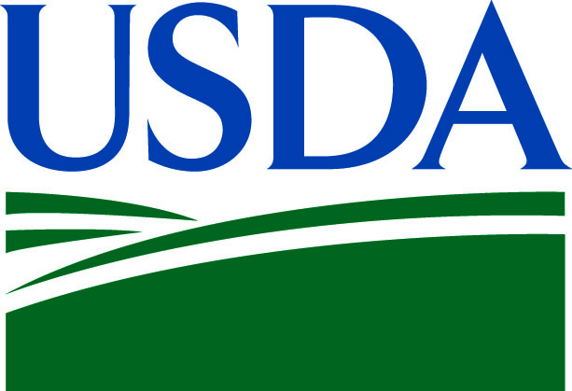  Forest Service

For Immediate Release:  July 28, 2016 | Contact: Eugene R. Peltola, Jr.  (907) 786-3888 or (800) 478-1456  subsistence@fws.gov
Federal Subsistence Board Approves Permit for 2016
Kenai River Community Gillnet Fishery

The Federal Subsistence Board (Board) has approved Emergency Special Action Request FSA16-02 with modification, providing for the issuance of a 2016 permit allowing for executing an experimental Kenai River community gillnet fishery for residents of Ninilchik.
The Board has stipulated that the fishery may be conducted in the Moose Range Meadows area of the Kenai National Wildlife Refuge, with a 10 fathom (60ꞌ) gillnet with 5 ¼" mesh, anchored to the bank. The fishery will allow the retention for up to 50 Chinook Salmon and any incidentally caught Rainbow Trout and Dolly Varden. Genetic samples will be collected from all Chinook Salmon. The State bank closures as adopted into Federal subsistence regulations shall be temporarily removed to allow for the Kenai River community gillnet fishery; however, Kenai National Wildlife Refuge regulations at 50 CFR 36.39(i) remain in effect and prohibit access within an area 25 feet upland of ordinary high water on either shore of the Kenai River between river miles 25.1 and 28.1. Additionally, this fishery shall be identified as experimental for 2016.
This Emergency Special Action will expire after 60 days or upon conclusion of the season for the Kenai River community gillnet fishery as defined in regulation or upon the retention of 50 Chinook Salmon.
Additional information on the Federal Subsistence Management Program may be found on the web at www.doi.gov/subsistence or by visiting www.facebook.com/subsistencealaska.
Missing out on the latest Federal subsistence issues? If you’d like to receive emails and notifications on the Federal Subsistence Management Program you may subscribe for regular updates by emailing fws-fsb-subsistence-request@lists.fws.gov.
-###-

