Interior’s Office of Policy Analysis Seminar
Outdoor Recreation Economy: Trends, Opportunities and Challenges
for Parks and Public lands
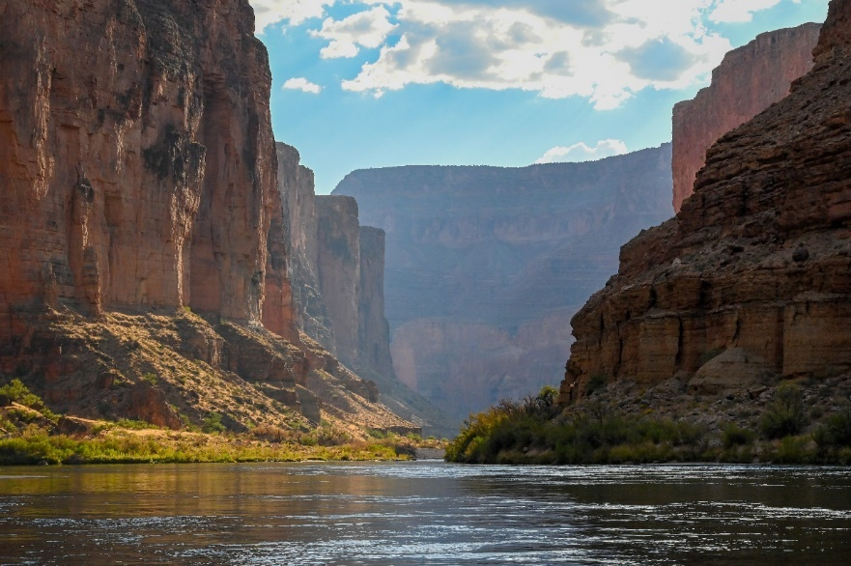
Moderator: Bob Ratcliffe - Chief, NPS Conservation and Outdoor Recreation Programs
Panelists:
Dirk van Duym, Research Economist, Bureau of Economic Analysis (BEA) Outdoor Recreation Satellite Account
Jessica Turner, Executive Director, Outdoor Recreation Roundtable.
Lynne Koontz, Economist, National Park Service. Social Science Program.
Rudy Schuster, Branch Chief, Social and Economic Analysis, USGS.
Benjamin Simon, Chief Department of the Interior Economist

Topic: Outdoor Recreation Economy: Trends, Opportunities and Challenges for Parks and Public lands
Date: September 13, 2021
Time: 12:15-1:45 pm (Eastern)
Webcast Only: Microsoft Teams Live Event (You can also use this link to access the recorded seminar after the event.)

Closed captioning (CC) is available. Just click the CC button on the Teams viewer.

Panel Description: Outdoor recreation and tourism are a significant component of the nation’s economy. The new U.S. data show that the outdoor recreation economy accounted for 2.1 percent ($459.8 billion) of current-dollar gross domestic product (GDP) for the nation in 2019. At the state level, outdoor recreation value added as a share of state GDP ranged from 5.8 percent in Hawaii to 1.3 percent in Connecticut. Parks and public lands play a crucial role in sustaining and supporting national, state, regional and local community economies and quality of life. Investment in parks and public lands is now widely understood to be essential for sustaining resilient economic strategies. More recently the outdoor recreation economy has demonstrated its importance in accelerating post-COVID economic and health recovery. Understanding visitor trends, economic contribution, industry conditions, and furthering research and social/economic science is critical for good park and public land policy and management decisions for sustainable recreation. This panel will provide a broad overview of the outdoor recreation economy and trends from national economic and industry perspectives as well as updates on social science program challenges and opportunities from departmental and agency social science leaders.

To view the Live Event, please click on the link above. Join 5-10 minutes early to avoid technical difficulties.
To view the recorded event, click on the link above (following the event).
The public is welcome to join the Microsoft Live (or recorded) Teams Event.
Interior Department employees seeking training credits: This seminar meets one hour of Executive Education training. To document your attendance, preregister via DOI Talent. Be sure to return to DOI Talent to mark yourself complete following the seminar.
For additional information about this event, please contact Malka Pattison at: Malka_pattison@ios.doi.gov

