Interior’s Office of Policy Analysis Seminar
Rigs to Reefs: Decommissioning Oil and Gas Platforms into Artificial Reefs

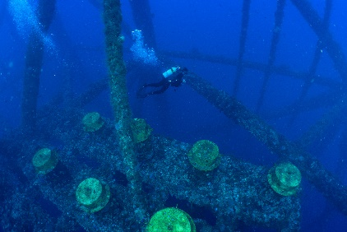
Photo Credit: GP Schmahl, NOAA

Speaker: Douglas Peter, Artificial Reef Coordinator, Bureau of Safety and Environmental Enforcement, New Orleans, Louisiana
Topic: Rigs to Reefs: Decommissioning Oil and Gas Platforms into Artificial Reefs
Date: Monday, April, 12, 2021
Time: 12:15 - 1:15 pm (Eastern)
Webcast Only: Microsoft Teams Live Event (You can also use this link to access the recorded seminar after the event.)

Closed captioning (CC) is available. Click the CC button on the Teams viewer.

The Bureau of Safety and Environmental Enforcement (BSEE) promotes and enforces safety and environmental stewardship throughout the offshore energy exploration, production and decommissioning lifecycle. The Minerals Management Service, the predecessor of BSEE, was key in developing artificial reef policy as well as the regulatory requirements under 30 CFR §250.1730, allowing the conversion of platforms that were no longer useful to artificial reefs. These structures continue to attract and sustain ocean life, as well as provide fishing and diving opportunities. BSEE continues to coordinate and facilitate the conversion of appropriately decommissioned oil and gas platforms from operators to a designated State artificial reef program. This presentation will explore the process and history of “Rigs to Reef” in the Gulf of Mexico, which has successfully converted over 500 oil and gas platforms into artificial reefs.

To view the Live Event, please click on the link above. Join 5-10 minutes early to avoid technical difficulties.

To view the recorded event, click on the link above (following the event).

The Public is Welcome to join the Microsoft Live (or recorded) Teams Event.

Interior Department employees seeking training credits: This seminar meets one hour of Executive Education training. To document your attendance, preregister via DOI Talent. Be sure to return to DOI Talent to mark yourself complete following the seminar.

For additional information about this event, please contact Malka Pattison

