DOI Office of Policy Analysis Seminar
Harriet Tubman, An American Hero
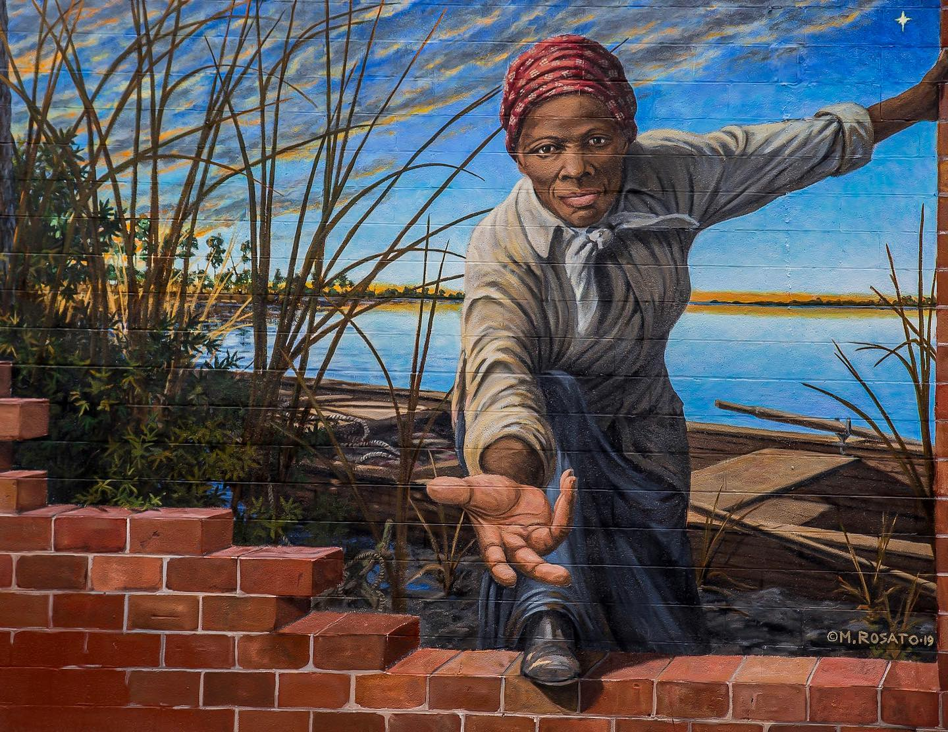
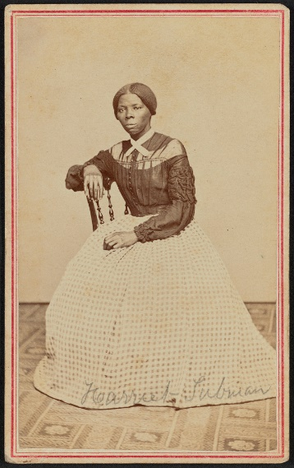

Photo Credits: Maryland Office of Tourism; Library of Congress

Speaker: Diane Miller, Program Manager, National Underground Railroad Network to Freedom, National Park Service
Moderator: Amanda Pollock, Visual Information Specialist, National Underground Railroad Network to Freedom, National Park Service
Topic: Harriet Tubman, An American Hero
Date: Monday, February 8, 2021
Time: 12:15pm – 1:15pm (Eastern)
Location: Due to COVID-19, there will be no live audience
Webcast ONLY: Microsoft Teams Live Event (You can also use this link to access the recorded seminar after the event)
Closed caption (CC) is available by clicking the CC button on the viewer that comes up on Teams.
Please join DOI Office of Policy Analysis to learn about the life of Harriet Tubman, perhaps the most famous Underground Railroad conductor. Born on the eastern shore of Maryland in 1822, Tubman escaped slavery in 1849, fearing that she would be sold following the death of her enslaver. Recounting her liberation, Tubman recalled “there was no one to welcome me to the land of freedom. I was a stranger in a strange land.” Longing for her family, Tubman made 13 rescue missions, leading about 70 family and friends to freedom. Her activism continued through the Civil War when she nursed the wounded, was a scout, cook, and spy, leading U.S. troops on a raid that liberated over 700 enslaved people. Tubman was an active suffragist and opened a Home for the Aged to care for impoverished elders. Today, two national parks honor her memory, along with the Harriet Tubman Underground Railroad Byway and a Maryland state park. Popular culture references to her story have exploded in recent years.
To view the Live Event, please click on the link above. Join 5-10 minutes early to avoid technical difficulties.
To View the recorded event, click on the link above (following the event).
The public is welcome to join the Microsoft Live (or recorded) Teams Event.
For Interior Department Registrants Only: This seminar meets one hour of Executive Education training. To document your attendance, register via DOI Talent. Be sure to return to DOI talent to mark yourself complete following the seminar.
For additional information about this event, please contact Malka Pattison at: malka_pattison@ios.doi.gov

