Interior’s Office of Policy Analysis Seminar
Using citizen science to support resource management

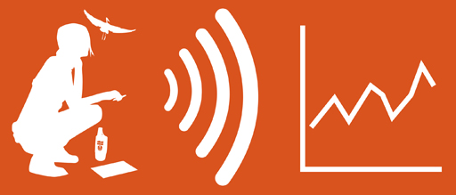

Presenters:
Jana Newman, PhD, Ecologist, U.S. Fish and Wildlife Service
Michelle Donlan, Ed.D, Training and Education Specialist, U.S. Fish and Wildlife Service

Topic: Using citizen science to support natural resource management
Date: October 18, 2021
Time: 12:15-1:15 pm (Eastern)
Place: Due to COVID-19 precautions, there will be no live audience
Webcast Only: Microsoft Teams Live Event (You can also use this link to access the recorded seminar after the event.)

Closed captioning (CC) is available. Just click the CC button on the Teams viewer.

Incorporating citizen science support and information helps the U.S. Fish and Wildlife Service (Service) achieve its mission to conserve, protect, and enhance fish and wildlife and their habitats for the continuing benefit of the American people. Citizens across the U.S. share their observations to enhance management of the National Wildlife Refuge System (NWRS), which encompasses more than 850 million acres of land and water in the U.S. and its territories. The speakers will describe how citizen science is used to support the Service’s biological program. They will present examples from partnerships and collaboration with the USA-National Phenology Network, Monarch Joint Venture, and eBird. They will also identify training efforts developed in cooperation with other federal agencies.

To view the Live Event, please click on the link above. Join 5-10 minutes early to avoid technical difficulties.

To view the recorded event, please click on the link above (following the event).
The public is welcome to join the Microsoft Live (or recorded) Teams Event.
Interior Department employees seeking training credits: This seminar meets one hour of Executive Education training. To document your attendance, preregister via DOI Talent. Be sure to return to DOI Talent to mark yourself complete following the seminar.
For additional information about this event, please contact Malka Pattison: malka_pattison@ios.doi.gov

