Interior’s Office of Policy Analysis Seminar
Natural Capital Accounting: Bridging the Nation’s economic accounts & natural resources for improved management

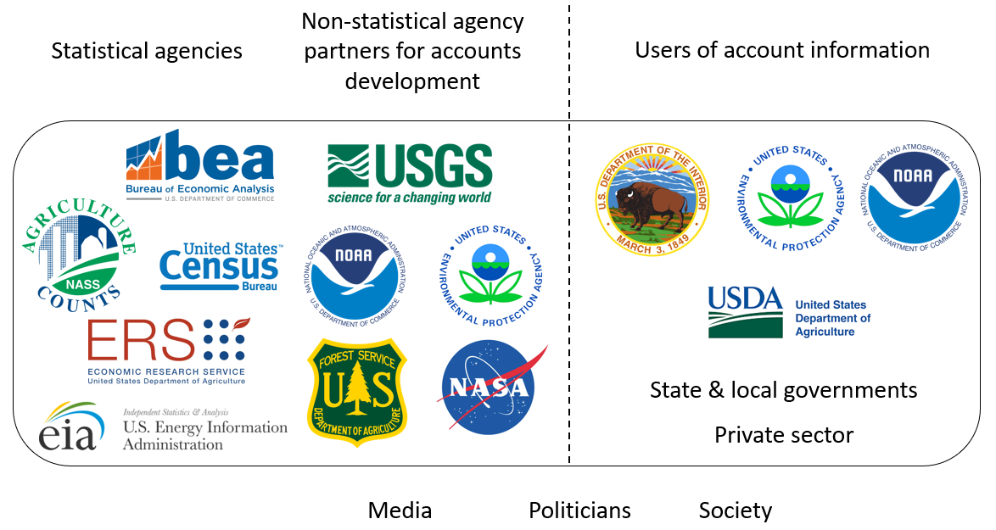

Panelists:
Ken Bagstad, Research Economist, U.S. Geological Survey
Carter Ingram, Senior Manager in Sustainability Services, Ernst & Young
Carl Shapiro, Director, U.S. Geological Survey Science and Decisions Center
Monica Grasso, Chief Economist, National Oceanic and Atmospheric Administration
Ben Simon, Chief Economist, Department of the Interior Office of Policy Analysis

Topic: Natural Capital Accounting: Bridging the Nation’s economic accounts & natural resources for improved management
Date: January 11, 2021
Time: 12:15-1:45 pm (Eastern)
Webcast Only: Microsoft Teams Live Event (You can also use this link to access the recorded seminar after the event.)

Closed captioning (CC) is available. Just click the CC button on the viewer that comes up on Teams.

Natural capital accounting (NCA) is being used globally by the private and public sectors to track changes in ecosystem services – the value nature provides to society. An interagency working group begun in 2016 and funded by USGS and others recently completed the first synthesis of natural resources and economic data needed to produce an initial set of NCAs for the United States at both national and subnational scales. Our approach aims to provide a rigorous and replicable assessment process to support more sustainable natural resource management for Federal agencies, the private sector, and others. This panel will describe (1) approaches to quantifying changes in the supply, use, and value of land, water, ecosystems, and other assets to the U.S. economy, (2) lessons learned in the process, including both successes and remaining limitations to accurate NCA in the U.S., and (3) next steps needed to connect NCA users and producers, ensuring that their production adds value to decision making.

To view the Live Event, please click on the link above. Join 5-10 minutes early to avoid technical difficulties.
To view the recorded event, click on the link above (following the event).
The public is welcome to join the Microsoft Live (or recorded) Teams Event.
For Interior Department Registrants Only: This seminar meets one hour of Executive Education training. To document your attendance, register via DOI Talent. Be sure to return to DOI Talent to mark yourself following the seminar.
For additional information about this event, please contact Malka Pattison at: Malka_pattison@ios.doi.gov

