Interior’s Office of Policy Analysis Seminar
Open Ocean Wave Energy Testing
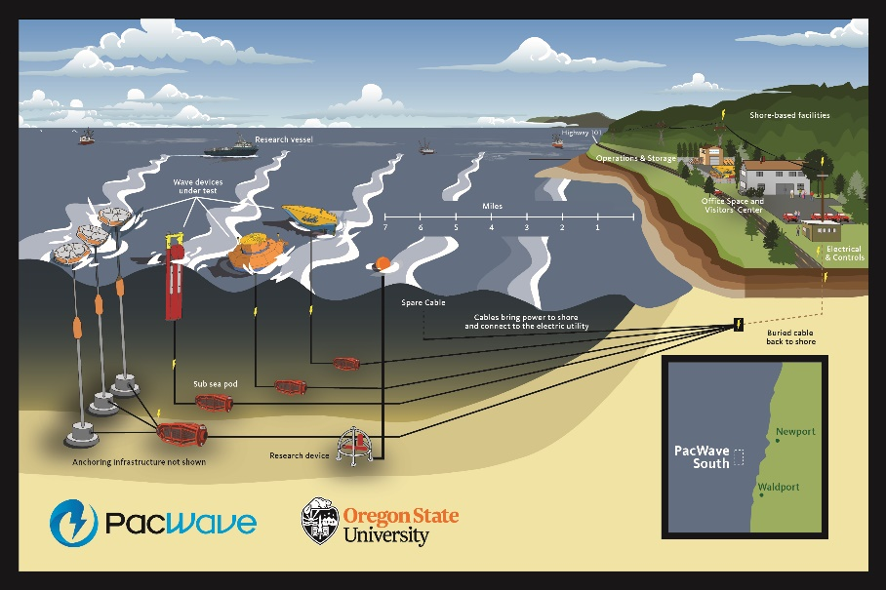

Panelists:
- U.S. Department of Energy, Tim Ramsey
- PacWave, Justin Klure
- Bureau of Ocean Energy Management, Whitney Hauer
- Federal Energy Regulatory Commission, Paige Espy
Topic: Open Ocean Wave Energy Testing
Date: October 17, 2022
Time: 12:15-1:45 pm (Eastern)
Webcast Only: Microsoft Teams Live Events (You can also use this link to access the recorded seminar after the event.)

Closed captioning (CC) is available. Just click the CC button on the viewer that comes up on Teams.

Marine energy technologies convert the energy of waves, tides, river and ocean currents into electricity to power homes and buildings. The panel will discuss wave energy as an emerging technology and describe the roles of the various entities to advance it. PacWave South is a grid-connected, full-scale test facility for wave energy devices offshore Newport, Oregon, and the first of its kind in the United States. The facility, owned and operated by Oregon State University, is pre-permitted to test wave energy devices. The panel will also discuss the regulatory process for leasing and licensing the facility as jurisdiction for grid-connected wave energy projects in federal waters is shared by the Bureau of Ocean Energy Management and the Federal Energy Regulatory Commission.

To view the Live Event, please click on the link above. Join 5-10 minutes early to avoid technical difficulties.
To view the recorded event, click on the link above (following the event).
The public is welcome to join the Microsoft Live (or recorded) Teams Event.
For Interior Department Registrants Only: This seminar meets one hour of Executive Education training. To document your attendance, preregister via DOI Talent. Be sure to return to DOI Talent to mark yourself complete following the seminar.
For additional information about this event, please contact malka_pattison@ios.doi.gov

