Interior’s Office of Policy Analysis Seminar
Conservation Across Jurisdictions: Biodiversity Data for Decision Making

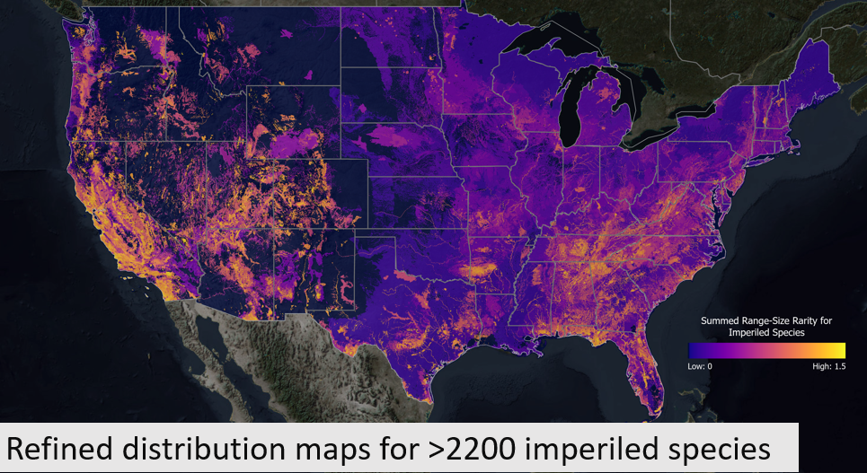

Panelists:
- Dr. Healy Hamilton, Chief Scientist, NatureServe
- Neil Cox, Biodiversity Assessment Unit, Conservation International
- Dr. Tracy Farrell, Director, International Union for Conservation of Nature (IUCN) North America

Date: Monday Sept 12, 2022
Time: 12:15-1:45 pm (Eastern)
Webcast Only: Microsoft Teams Live Event (You can also use this link to access the recorded seminar after the event.)

Closed captioning (CC) is available. Just click the CC button on the viewer that comes up on Teams.

Biodiversity is the foundation of the economic and ecological wellbeing of human societies. We depend on the diversity of genes, species and ecosystems as a source of goods and services with annual values in the trillions of dollars, irreplaceably provided by nature. The conservation and management of biodiversity is essential to building community and sector resilience to the forces of global change. To effectively and efficiently conserve biodiversity and reduce conflict with development pressures, foundational information is required on the identity, distribution, and conservation status of species and ecosystems. This information must be standardized and widely accessible to conserve the species and ecosystems that cross political boundaries and agency jurisdictions. Technological innovations are bringing new efficiencies and expanded inclusivity to how these fundamental biodiversity data are created and shared. The panelists represent organizations committed to developing, maintaining, and disseminating foundational species and ecosystems to support all stakeholders, including many DOI bureaus, in the management and effective conservation of the biodiversity upon which we all depend.

To view the Live Event, please click on the link above. Join 5-10 minutes early to avoid technical difficulties.
To view the recorded event, click on the link above (following the event).
The public is welcome to join the Microsoft Live (or recorded) Teams Event.
For Interior Department Registrants Only: This seminar meets one hour of Executive Education training. To document your attendance, register via DOI Talent. Be sure to return to DOI Talent to mark yourself complete following the seminar.
For additional information about this event, please contact Malka Pattison at: malka_pattison@ios.doi.gov

