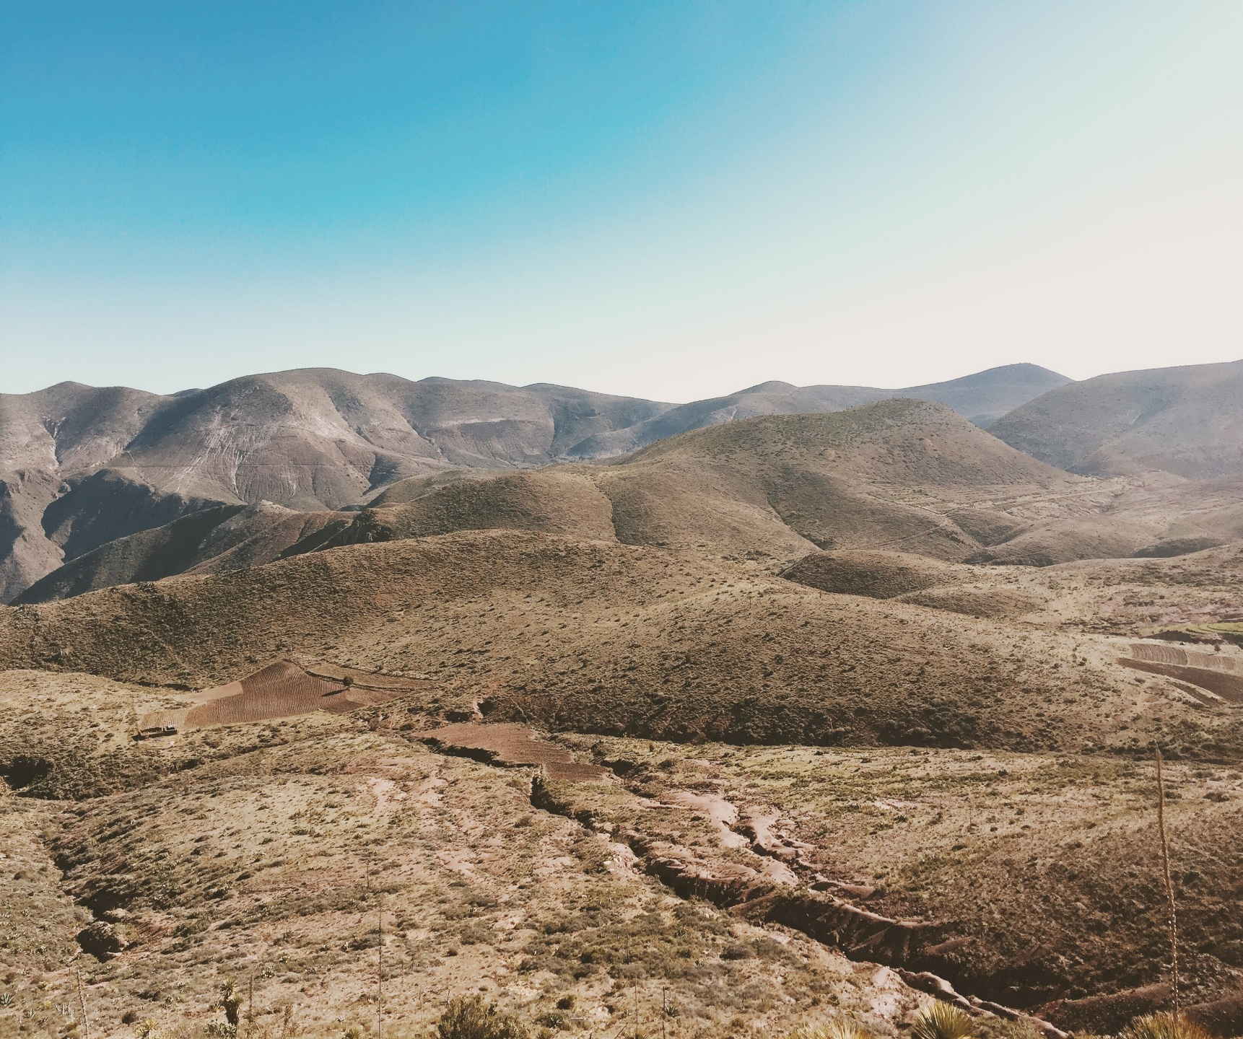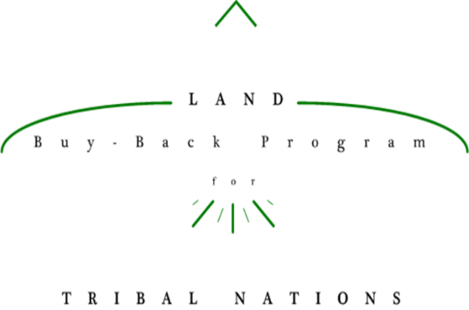

Must receive Tribal approval to use crest/seal.

<Insert Tribal Crest/Seal>

**Land Buy-Back Program**

**Offers Due by <Month/Day>**

<SAMPLE IMAGE ONLY>

**If you received a Buy-Back Program offer for land at <Reservation Name> and are interested in selling, make sure to complete and return your offer by <Month Day>**

**Have Questions?**

**Call the Trust Beneficiary Call Center at 1-888-678-6836**

**Call our Tribal Office at <Phone Number>**

**Visit our office in person at <Address>**

**Visit the <BTFA Agency Name>**