Department of the Interior’s (DOI) Office of Policy Analysis Seminar
U.S. Geological Survey (USGS): Providing Data and Tools for Resilient Coastal Resources, Communities, and Economies
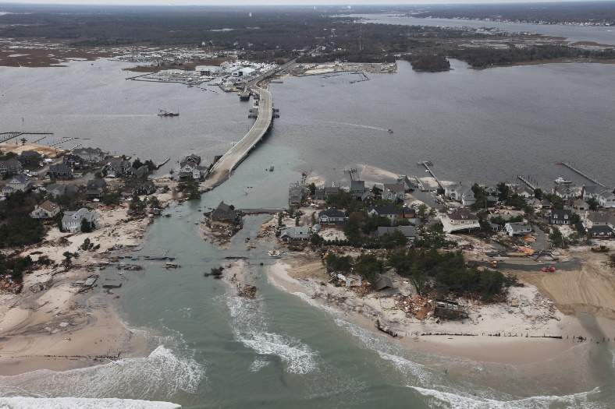
Photo: Greg Thompson, USFWS. Public domain.
Mantoloking, NJ post-Hurricane Sandy. 2012.
Topics: Coastal resilience, DOI lands, natural hazards, sea-level, coastal change, and stakeholder engagement

Panelists:
Dr. Margaret Palmsten, Research Oceanographer, U.S. Geological Survey
(Saint Petersburg Coastal and Marine Science Center)
Dr. Jon Warrick, Research Geologist, U.S. Geological Survey
(Pacific Coastal and Marine Science Center)
Dr. Davina Passeri, Research Oceanographer, U.S. Geological Survey
(Saint Petersburg Coastal and Marine Science Center)
Dr. Jennifer Miselis, Research Geologist, U.S. Geological Survey
(Saint Petersburg Coastal and Marine Science Center)
Dr. Lauren Toth, Research Physical Scientist, U.S. Geological Survey
(Saint Petersburg Coastal and Marine Science Center)

Date: June 13, 2022
Time: 12:15 –1:45 PM (Eastern)
Webcast Only: Microsoft Teams Live Event (You can also use this link to access the recorded seminar after the event.)

Closed captioning (CC) is available. Just click the CC button on the viewer that comes up on Teams.

Coasts are threatened by sea-level rise, extreme storms, erosion, and loss of ecosystems. The DOI has a broad range of stewardship responsibilities related to managing coastal resources that communities and the Nation depend on. Scientific understanding of these threats and forecasting their potential impacts are crucial for providing robust information to guide coastal restoration and management strategies, including an emphasis on underserved communities. USGS coastal science has helped address coastal management challenges in national parks, refuges and other coastal areas. In this seminar, you will hear about coastal modeling and forecasting of storm and sea-level rise impacts, assessing landscape change with new imaging technologies, and evaluating impacts of coral reef degradation and sediment availability. Learn how USGS is working to share this knowledge with DOI and other stakeholders working on-the-ground.
To view the Live Event, please click on the link above. Join 5-10 minutes early to avoid technical difficulties.

To view the recorded event, click on the link above (following the event).

The public is welcome to join the Microsoft Live (or recorded) Teams Event.
For Interior Department Registrants Only: This seminar meets one hour of Executive Education training. To document your attendance, register via DOI Talent. Be sure to return to DOI Talent to mark yourself complete following the seminar.

For additional information about this event, please contact Malka Pattison at: Malka_pattison@ios.doi.gov

