Interior’s Office of Policy Analysis Seminar
150 Years of Yellowstone
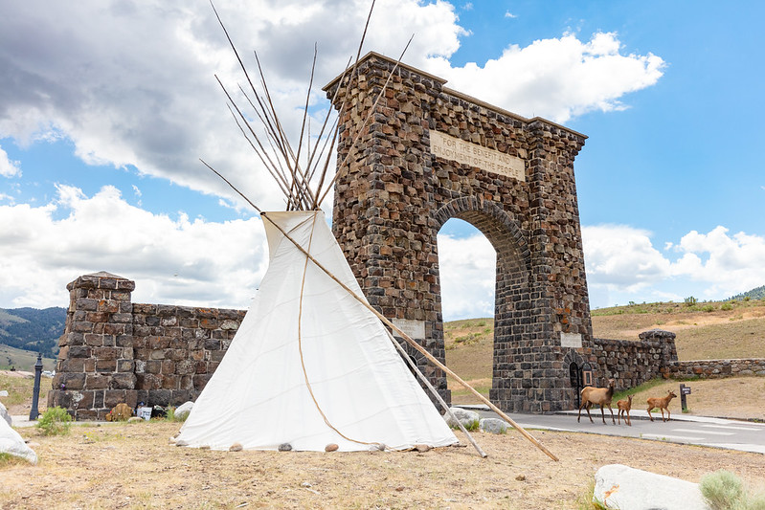

Speakers: Cam Sholly, Superintendent, Yellowstone National Park
Christina White, Chief of External Affairs and Partnerships, Yellowstone National Park
Topic: 150 Years of Yellowstone National Park
Date: November 14, 2022
Time: 12:15-1:15 PM (Eastern Time)
Webcast Only: Microsoft Teams Live Events (link to both the live and recorded event)

Yellowstone as a national park was born on March 1, 1872 -- making it the world's first national park. When President Ulysses S. Grant signed the Yellowstone National Park Protection Act into law, it federally protected more than 2 million acres of mountain wilderness, amazing geysers, and vibrant landscapes for future generations to enjoy. Prior to 1872, the area now known as Yellowstone National Park was cared for and used by twenty-seven tribes. It remains an area of great historical and modern significance for tribes, visitors, locals, and people worldwide.

Our goal is to reflect on 150 years of protecting Yellowstone National Park, to highlight successes within the ecosystem, and to open dialogue on the lessons learned from yesterday, the challenges of today, and our vision for tomorrow. We are using this 150th year as a park to not just to celebrate, but to strengthen relationships with tribes, partners, and the public to make a lasting positive impact on the next 150 years of Yellowstone.

To view the Live Event, please click on the link above. Join 5-10 minutes early to avoid technical difficulties.

To view the recorded event, please click on the link above (following the event).

The public is welcome to join the Microsoft Live (or recorded) event.

For Interior Department Registrants Seeking Training Credits: This seminar meets one hour of Executive Education training. To document your attendance, pre-register via DOI Talent. Be sure to return to DOI Talent to mark yourself complete after you have attended the seminar.

For additional information about this event, please contact malka_pattison@ios.doi.gov

