Interior’s Office of Policy Analysis Seminar
The Ambassador’s Water Experts Program - Stories of Water Diplomacy
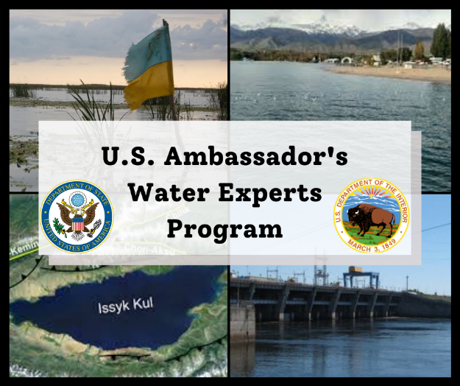
Speakers:
- Elisabeth Ericson, Foreign Affairs Officer, U.S. Department of State, Bureau of Oceans and International Environmental and Scientific Affairs, Office of Conservation and Water
- Nicholas (Nick) Aumen, Regional Science Advisor – South Florida, U.S. Geological Survey
- Roman Ferdinand, Program Analyst, Office of Surface Mining Reclamation and Enforcement
- Stephen (Steve) Kolk, Upper Columbia Sub-basin Liaison, U.S. Bureau of Reclamation
Moderator:
- Elizabeth Goffi, Project Manager, DOI’s International Technical Assistance Program (DOI-ITAP)
Topic: International Capacity Building in Water Resources Management
Date: May 10, 2021
Time: 12:15 – 1:45 EST
Webcast Only: Microsoft Teams Live Event (You can also use this link to access the recorded seminar after the event.)

Closed captioning (CC) is available. Click the CC button on the viewer displayed in Teams.
Increased or sustained water stress has the potential to spread disease, undermine economic growth, foster insecurity and state failure, and reduce the capacity of countries to advance priorities that support U.S. national interests. Under the U.S. Global Water Strategy, the Ambassador’s Water Experts Program (AWEP) provides short-term technical assistance for water security, targeting sustainable infrastructure and services, and promoting science, technology, and information exchange. AWEP is managed by the U.S. Department of the Interior’s International Technical Assistance Program with funding from the State Department’s Bureau of Oceans and International Environmental and Scientific Affairs. Join us on May 10th as DOI experts review their successful trips to Ukraine and Kyrgyzstan and learn more about how you, too, can participate in future virtual and in-person AWEP assignments.
To view the Live Event, please click on the link above. Join 5-10 minutes early to avoid technical difficulties.
To view the recorded event, click on the link above (following the event).
The public is welcome to join the Microsoft Live (or recorded) Teams Event.
For Interior Department Registrants Only: This seminar meets one hour of Executive Education training. To document your attendance, register via DOI Talent. Be sure to return to DOI Talent to mark yourself complete after you have attended the seminar.
For additional information about this event, please contact Malka Pattison at: Malka_pattison@ios.doi.gov

