Interior’s Office of Policy Analysis Seminar
Offshore Wind: BOEM Renewable Energy Program Overview

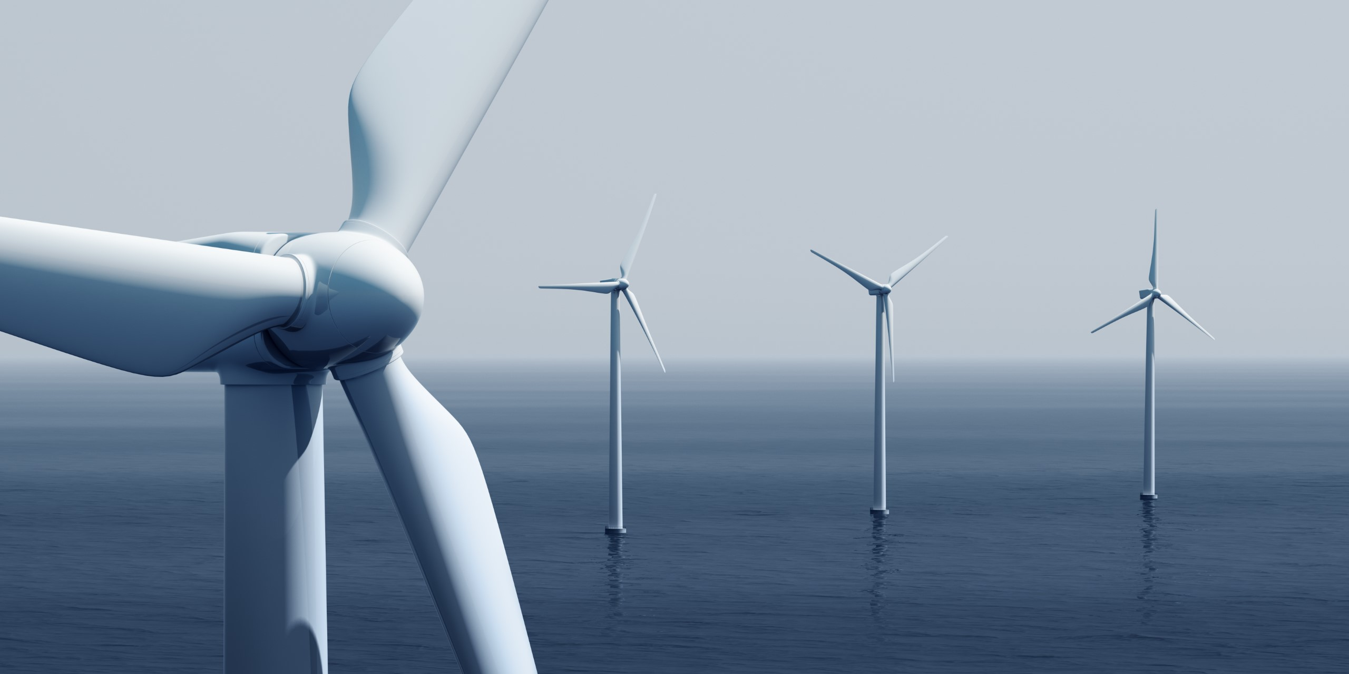

Speaker: Jim Bennett, Chief, Office of Renewable Energy Programs, BOEM
Topic: Offshore Wind
Date: Monday, April 11, 2022
Time: 12:15 PM – 1:15 PM (Eastern)
Webcast Only: Microsoft Teams Live Event (You can also use this link to access the recorded seminar after the event.)

Closed captioning (CC) is available. Click the CC button on the Teams viewer.

The domestic offshore wind industry is advancing rapidly and poised to become one of the fastest growing renewable energy sources in the United States. The continued growth in the U.S offshore market reflects decreasing global costs, advancing technology, stronger state policy commitments, and the Administration's commitment to American Energy – 30 GW of offshore wind by 2030. Come learn about the Bureau of Ocean Energy Management's Renewable Energy Program and get the most recent updates on the future of offshore wind.

To view the Live Event, please click on the link above. Join 5-10 minutes early to avoid technical difficulties.

To view the recorded event, click on the link above (following the event).

The Public is Welcome to join the Microsoft Live (or recorded) Teams Event.

Interior Department employees seeking training credits: This seminar meets one hour of Executive Education training. To document your attendance, preregister via DOI Talent. Be sure to return to DOI Talent to mark yourself complete following the seminar.

For additional information about this event, please contact Malka Pattison

