Interior’s Office of Policy Analysis Seminar
Seeding the Future: Restoring Native Plant Communities

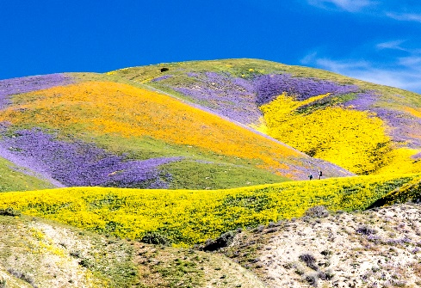
Carrizo Plain National Monument during the 2017 superbloom. Photo by Bob Wick/BLM

Speaker: Peggy Olwell, Program Lead, BLM Plant Conservation and Restoration Program
Topic: Seeding the Future: Restoring Native Plant Communities
Date: March 14, 2022
Time: 12:15-1:15 pm (Eastern)
Webcast Only: Microsoft Teams Live Event (You can also use this link to access the recorded seminar after the event.)

Closed captioning (CC) is available. Click the CC button on the Teams viewer.

Learn how the Bureau of Land Management (BLM) and other members of the Plant Conservation Alliance (PCA) are working to restore healthy, biodiverse, and resilient ecosystems. The PCA is a public-private coalition of about 15 Federal agencies and more than 400 non-federal cooperators. In 2015, the PCA developed the National Seed Strategy for Rehabilitation and Restoration to increase the availability of locally adapted native seed for restoration. PCA members and partners have made significant progress implementing the National Seed Strategy during its first five years, but our work has only begun. To truly “seed” the future, we need to develop national policy​ on native seed development and use, build botanical and ecological expertise​ throughout the land managing agencies, and develop a National Seed and Restoration Center for cross-institutional coordination and implementation. ​

To view the Live Event, please click on the link above. Join 5-10 minutes early to avoid technical difficulties.

To view the recorded event, click on the link above (following the event).
The public is welcome to join the Microsoft Live (or recorded) Teams Event.
Interior Department employees seeking training credits: This seminar meets one hour of Executive Education training. To document your attendance, preregister via DOI Talent. Be sure to return to DOI Talent to mark yourself complete following the seminar.
For additional information about this event, please contact malka_pattison@ios.doi.gov

