Department of the Interior Fiscal Year 2025 Economic Contributions

Produced By: DOI Office of Policy Analysis Updated: February 24, 2026

Economic Contributions from the Department’s Core Work
Estimating economic contributions is one of several ways that the Department of the Interior (Department; DOI) demonstrates transparency in how its activities support the U.S. economy and its people. These estimates reflect how the Department’s core expenditures – the activities the Department engages in to fulfill its mission – contribute to the economy in terms of jobs and gross domestic product (GDP).

Core expenditures capture a range of DOI’s activities, namely Departmental Operations and Grants and Payments. Departmental Operations include activities performed and produced by Departmental employees, such as the development of reliable scientific information, supporting law enforcement on federal and Tribal lands, and managing resources to achieve Strategic Plan goals. Grants and Payments include direct assistance by a DOI Bureau or Office to eligible recipients to support or stimulate a public purpose such as wildfire management or water projects. This category also includes energy and mineral leasing revenues disbursed to state and local governments.

Fiscal Year 2025 Economic Contributions
In Fiscal Year 2025 the Department’s expenditures totaled $34.2 billion, which contributed $51.4 billion to the U.S. economy and supported over 428,000 jobs. Approximately 49% of the Department’s expenditures reflected grants and payments directed back to other sectors of the economy, largely through state, local, and Tribal governments.
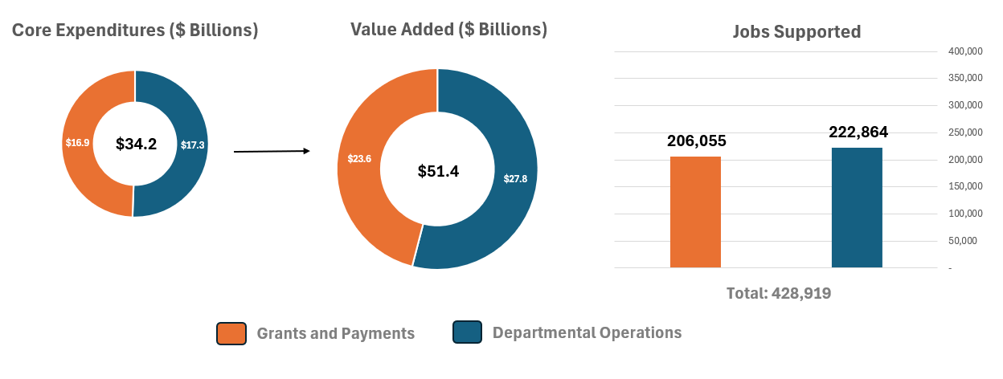

Using DOI Economic Contributions
The Department-wide estimates presented in this analysis provide a high-level view of the Department’s economic contributions as measured by spending and beneficiary disbursements. They should be viewed as a major, but not comprehensive portion of the activities supported by and the economic contributions created by the Department and its Bureaus and Offices.
These estimates are produced independently from Bureau-level estimates and due to differences in methodology and scope, they should not be interpreted as an aggregate of Bureau-level estimates. Additionally, Bureau-level estimates capture Department-wide core expenditures and should not be combined with each other or with the estimates presented here to create an ad-hoc estimate of total Department contributions, which would likely result in double-counting.
For Bureau-level estimates that provide a more detailed view of the economic impact of activities occurring on public lands, please refer to the following resources:
- Bureau of Land Management here
- Bureau of Ocean Management & Bureau of Safety and Environmental Enforcement here
- National Park Service here

Methodology
Over the years, the Office of Policy Analysis has developed various economic contribution estimates, each differing in analytical scope, data, and methodology. In Fiscal Year 2025, the Office narrowed how the Department-wide economic contributions are estimated. This change introduced efficiencies by utilizing fewer data sources and improving the timeliness of the Department’s fiscal year estimates.

Methods
The estimates employ activity-level response coefficient estimates using IMPLAN (an input-output software and data system) to derive economic multipliers. The economic data from IMPLAN come from the system of national accounts for the United States: data collected by the U.S. Department of Commerce’s Bureau of Economic Analysis, the U.S. Department of Labor’s Bureau of Labor Statistics, and other federal and state agencies.
The response coefficients used in this analysis estimate the total impacts of the Department-wide activities analyzed. That is, the response coefficients used are equal to the sum of direct, indirect, and induced effects for value added and jobs supported.
The Office of Policy Analysis sourced data on the Department’s core expenditures from administrative databases managed by the DOI Business Integration Office. These expenditure data were provided to the Office in different sub-categories based on the underlying source(s). The data were then bridged to IMPLAN’s economic event types by sub-category. Table 1 below summarizes how each Department core expenditure category consists of these sub-categories of expenditures, and how these sub-categories were linked to IMPLAN event types.

Data Year
The model assumes the structure of the Fiscal Year 2025 economy is similar to Calendar Year 2023, the most recent year with complete economic data in the IMPLAN software.

Dollar Year
All estimates are presented in 2025 dollars to account for inflation.

Region
A national-level model is used, assuming the Department’s activities largely rely on U.S.-based contractors and supply chains, regardless of activity location.

Fiscal Year
The dollar value input into the model reflects the value that the Department obligated in Fiscal Year 2025. Exceptions to this are the Office of Natural Resource Revenue data, which reflects disbursements as reported on the Office’s website.

Scope
For purposes of this report, core activities generally do not include the economic contributions generated by non-Department actors – that is, activities performed by other public or private sector entities on Department-managed lands and waters (e.g., recreation, grazing, mineral extraction or energy generation). Data on private sector spending and production are not directly included in the DOI core expenditures used for this analysis, however some of these core expenditures may originally result from revenues stemming from private activity on Department-managed land. Examples of this include energy and mineral leasing revenues disbursed to state and local governments.

Review
This analysis was reviewed for technical merit through a peer review and by the Chief Economist of the Department of the Interior. Economists from the Bureau of Land Management, Bureau of Ocean Management, and the National Park Service reviewed this analysis for overall framing and presentation.

Table 1: Description of Department Primary Activities

Core Expenditure Category | Sub-Category | Sub-Category Description | IMPLAN Economic Event Type
Departmental Operations | Acquisitions | Procurement of supplies or services (including construction) by contract for the use by a DOI Bureau/Office through purchase or lease. Also called “contracting”. | Industry Output, with the exception of Institutional Spending Patterns for monies to federal, state and local governments.
Departmental Operations | Employee Compensation | DOI employee payroll including both gross pay and benefits. | Labor Income, with manual adjustment to account for direct effects.
Grants and Payments | Financial Assistance | Refers to the transferring of money, property in lieu of money, or other direct assistance by a DOI Bureau/Office to eligible recipients to support or stimulate a public purpose as authorized by statute(s) with specific authorities. While there are multiple types of Financial Assistance, the term “grants” is used as a general term. | Commodity Output, with exceptions for Household Income and Institutional Spending Pattern for select monies. Modeled by allocating grant payments to appropriate IMPLAN sectors based on best available information about the sectors likely affected by each grant program.
Grants and Payments | Office of Natural Resources Revenue (ONRR) | Energy and mineral leasing revenues (bonuses, rents, and royalties) disbursed to state and local governments. | Institutional Spending Pattern.
Departmental Operations and Grants and Payments | Non-Referencing | All other expenditures captured in DOI’s administrative financial database that are not considered within employee compensation, financial assistance, or acquisition business processes. | Institutional Spending Pattern, with Industry Output for select pension and health contributions.

