Statement by the U.S. Geological Survey
Oversight Hearing on the Importance of Domestically Sourced Raw Materials
for Infrastructure Projects
before the House Committee on Natural Resources
Subcommittee on Energy and Mineral Resources
March 21, 2017

The U.S. Geological Survey (USGS) would like to thank the Chairman and members of the subcommittee for the opportunity to discuss USGS activities to support the Nation’s understanding of domestically sourced raw materials. USGS has a variety of products relevant to the availability of minerals materials used in infrastructure. For one, USGS publishes the Mineral Commodity Summaries on an annual basis, which serves as the most complete Federal repository of information about nonfuel minerals mined in the United States, and addresses events, trends, and issues in the domestic and international minerals industries. In addition, the USGS also leads production of a variety of geologic and topographic maps which are essential for building projects and sourcing of materials. This testimony will discuss many of the basic raw materials which go into our infrastructure network, our topographic and geological mapping and specific examples of the consequences of the lack of geologic data.

Natural Materials Data

The construction of buildings, dams, roads, and bridges requires natural materials, primarily sand and gravel, crushed stone, cement, and iron and steel (Table 1). Natural aggregates include sand, gravel, and crushed stone. Aggregates are used in their natural state or after processing by crushing, washing, and sizing. They accounted for 87 percent, by weight, of nonfuel mineral materials produced in the United States in 2016. The estimated annual output of aggregates produced in the United States in 2016 was 2.3 billion metric tons.

Natural aggregates are high-volume, low-value commodities, which are produced in every State. The aggregate industry is highly competitive and is characterized by thousands of operations serving local or regional markets. Production costs vary widely depending on geographic location, the nature of the deposit, and the number and type of products produced. Transportation is a major factor in the delivered price. The cost of moving aggregates from the plant to the market often exceeds the sales price of the product at the plant. Because of the high cost of transportation, aggregates are generally marketed locally and the availability of local sources is an important factor in the total cost of infrastructure projects. Failure to assess the availability of these materials can lead to very large cost overruns or project non-viability. An example of a major construction project that failed to take aggregate availability into account was the Denver International Airport project which was budgeted to cost $2.8 billion but ended up costing $4.8 billion at completion in 1995. The $2 billion cost overrun was in part due to failure to assess availability of sand, gravel, crushed stone, and cement. ^{, 2}

Salient Statistics for Infrastructure Materials
(Million metric tons unless otherwise noted)
 |  | 2006 | 2007 | 2008 | 2009 | 2010 | 2011 | 2012 | 2013 | 2014 | 2015 | 2016e
Sand and gravel, construction:
 | Domestic production | 1,330 | 1,250 | 1,060 | 838 | 807 | 809 | 812 | 847 | 897 | 937 | 959
 | Consumption, apparent | 1,320 | 1,250 | 1,060 | 841 | 809 | 812 | 815 | 851 | 901 | 941 | 959
 | Net import reliance as % of consumption | 1 | (1) | (1) | (1) | (1) | (1) | (1) | (1) | (1) | (1) | (1)
Stone, crushed:
 | Domestic production | 1,780 | 1,650 | 1,450 | 1,160 | 1,160 | 1,160 | 1,180 | 1,200 | 1,250 | 1,330 | 1,370
 | Recycled material | 20.0 | 20.0 | 29.0 | 29.0 | 26.0 | 27.3 | 31.1 | 40.6 | 36.1 | 37.2 | 43.5
 | Consumption, apparent | 1,810 | 1,690 | 1,500 | 1,200 | 1,200 | 1,200 | 1,200 | 1,250 | 1,310 | 1,390 | 1,430
 | Net import reliance as % of consumption | 1 | 1 | 1 | 1 | 1 | 1 | 1 | 1 | 2 | 2 | 1
Cement:
 | Hydraulic cement production | 99.3 | 98.2 | 95.5 | 86.3 | 63.9 | 66.4 | 67.9 | 74.2 | 76.8 | 83.7 | 85.4
 | Clinker production | 87.4 | 86.1 | 78.4 | 56.1 | 59.8 | 61.2 | 67.2 | 69.4 | 74.4 | 76.0 | 77.0
 | Consumption, apparent | 128 | 128 | 116 | 96.8 | 71.5 | 71.2 | 72.2 | 77.9 | 81.8 | 93.3 | 96.2
 | Net import reliance as % of consumption | 25 | 27 | 19 | 11 | 8 | 8 | 7 | 7 | 7 | 11 | 13
Iron and Steel:
 | Domestic raw steel production | 98.2 | 98.1 | 91.9 | 59.4 | 80.5 | 86.4 | 88.7 | 86.9 | 88.2 | 78.8 | 80.0
 | Consumption, apparent | 120 | 116 | 102 | 63.0 | 80.0 | 90.0 | 98.0 | 98.0 | 107.0 | 99.0 | 94.0
 | Net import reliance as % of consumption | 17 | 16 | 13 | 11 | 6 | 7 | 11 | 12 | 30 | 22 | 16

Most natural aggregates are used as a construction material (94 percent of sand and gravel and 76 percent of crushed stone), and most are sourced in the United States. Aggregates can be used without any binder for a variety of construction or industrial applications, or they can be mixed with a matrix binding material such as hydraulic cement or dark bituminous pitch (asphalt). A common use of aggregates as a construction material is in transportation projects. With a large, complex economy, the United States requires a vast system of roads and highways. As of 2012, the most recent year for which detailed data are available, the United States had 4.1 million miles of roads, 1.0 million miles of which are maintained with Federal aid and 47,700 miles of which comprised the Interstate Highway System. On a tonnage basis, the most important materials used in road construction are sand and gravel and crushed stone aggregates. These materials are also used in hydraulic cement concrete, with asphalt, and as road base. In addition, steel is used as culvert pipe, reinforcements, and structural support.
Sand and Gravel
The level of construction activity and therefore the demand for construction materials determine the demand for sand and gravel. U.S. production of construction sand and gravel recorded a significant growth in the past 67 years, from 336 million metric tons in 1950 to 959 million metric tons in 2016 valued at $8.6 billion. There was a significant drop in demand for these materials in 2008-2009 due to the global recession and resultant economic slowdown. Production was from an estimated 4,100 companies and government agencies from about 6,300 operations in 50 States (Figure 1).
It is estimated that about 44 percent of sand and gravel was used as concrete aggregates; 25 percent for road base and coverings and road stabilization; 13 percent as asphaltic concrete aggregates and other bituminous mixtures; 12 percent as construction fill; 1 percent each for concrete products, such as blocks, bricks, and pipes; plaster and gunite sands; and snow and ice control; and the remaining 3 percent for filtration, golf courses, railroad ballast, roofing granules, and other miscellaneous uses.
Crushed Stone
Like sand and gravel, crushed stone is used mostly for construction purposes and consumption is controlled by the demand for construction materials. Demand for construction materials increased post World War II especially after the start of the construction of the Interstate Highway System in the 1950s. U.S. production of crushed stone recorded significant growth in the past 67 years, from 243 million metric tons in 1950 to 1.37 billion metric tons in 2016.
In 2016, 1.37 billion tons of crushed stone valued at more than $15.2 billion was produced by 1,410 companies operating 3,500 quarries, and 101 underground mines in 49 States (Figure 2). Ten States account for more than one-half of the total amount of crushed stone produced in the U.S. annually. Of the total crushed stone produced annually, about 70 percent was limestone and dolomite. It is estimated that 76 percent of the crushed stone consumed was used as construction material, mostly for road construction and maintenance with another 11 percent for cement manufacturing.

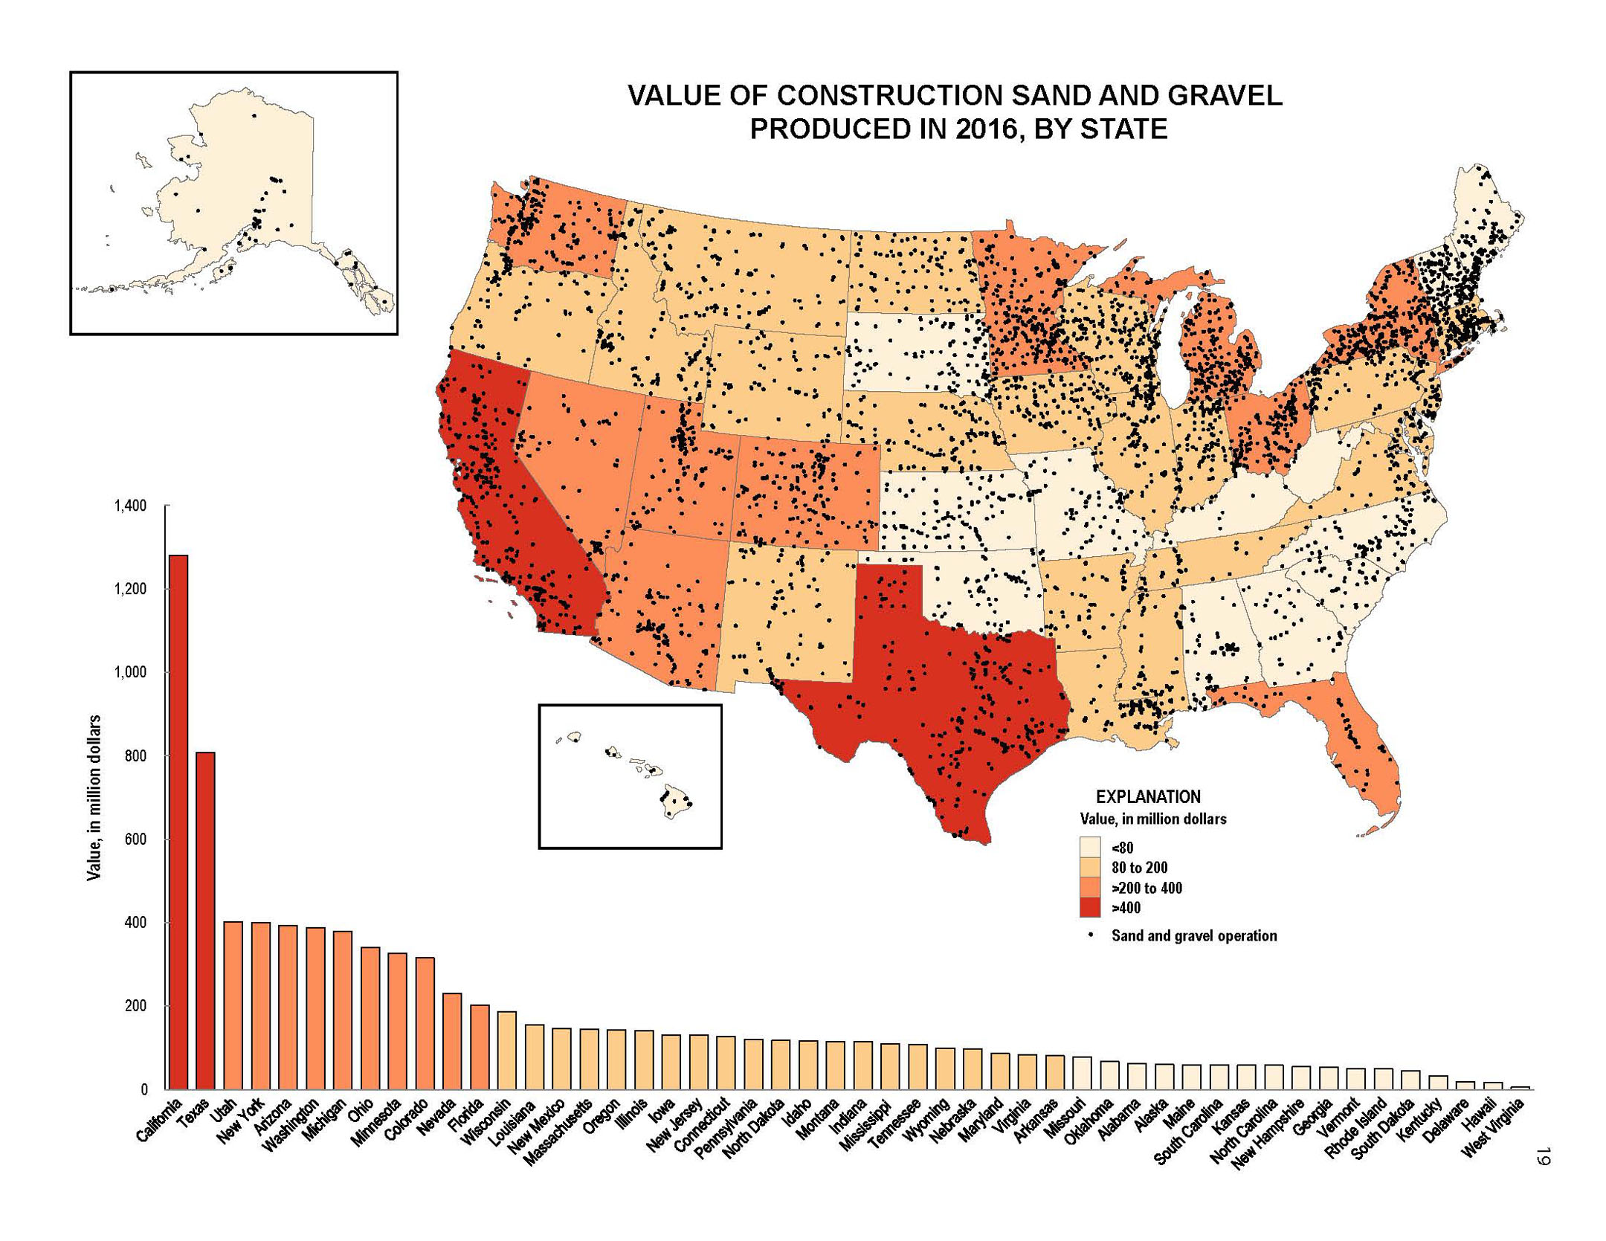
Figure 1. Sand and gravel production across the United States showing the locations of operation (black dots) and value of production by State. Data from the USGS.

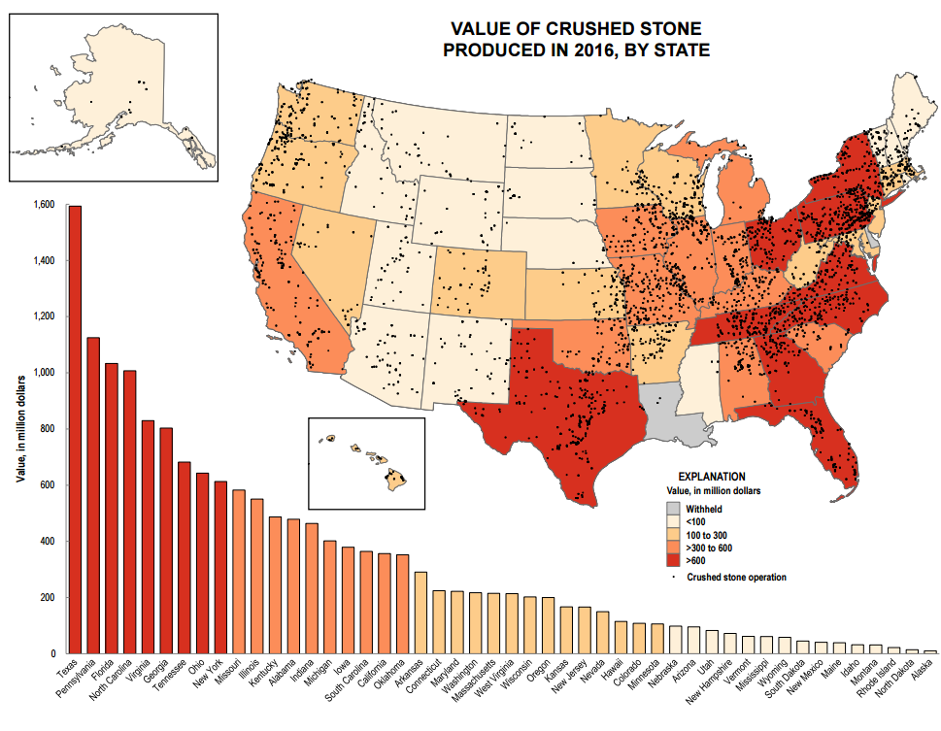
Figure 2. Crushed stone production across the United States showing the locations of operation (black dots) and value of production by State. Data from the USGS.
Hydraulic cement

Crushed limestone is used to make clinker that is used for cement and as an additive to bulk out hydraulic cement, to make certain types of blended cement, or to make most forms of masonry cement. Cement is produced in the United States at about 100 plants, in 32 states (Figure 3). Hydraulic cements (chiefly Portland cement or similar types that are based on Portland cement) are the binding agents in hydraulic cement concrete (concrete) and in most types of mortars and stuccos. The term “hydraulic” refers to the fact that the cement sets (stiffens), hardens, and develops strength through the chemical combination of its component compounds (“minerals”) with water; i.e., through hydration. It is widely used in infrastructure as bases and subbases for roads, road paving, bridge abutments, pillars, and decks; pipes and culverts; dams; and soil stabilization, as well as in building construction.

Limestone is the primary raw material for cement (clinker) manufacturing. Limestone is geologically abundant and generally widespread. The low unit value of limestone generally precludes the material being transported long distances unless inexpensive water transportation is available. There are portions of the country that lack significant limestone such as much of New England, the northern tier (Minnesota, North Dakota, Wisconsin), large portions of the northwest (northern California, Oregon, and Washington), and the border area of south Texas where limestone must be imported (Figure 3). Even in areas with significant limestone, reserves may be limited at specific (older) cement plants and a cement plant may face constraints on its limestone reserves if the plant-quarry complex is being encroached upon by housing, if land costs are high, or because of zoning prohibitions.

Iron and steel

Iron or steel reinforcing rods or bars (rebar) or mesh are embedded in cement to provide adequate tensional strength in most forms of concrete construction; this combination is called reinforced concrete. Construction products are the leading single end-use market for steel in the United States. The iron and steel industry and ferrous foundries in the United States produced goods in 2016 with an estimated value of about $130 billion. Pig iron was produced by three companies operating integrated steel mills in 11 locations. About 55 companies produce raw steel at 108 minimills. Combined production capacity was about 111 million tons. Indiana accounted for 29% of total raw steel production, followed by Ohio, 11%; Michigan, 7%; and Pennsylvania, 6%, with no other State having more than 5% of total domestic raw steel production.

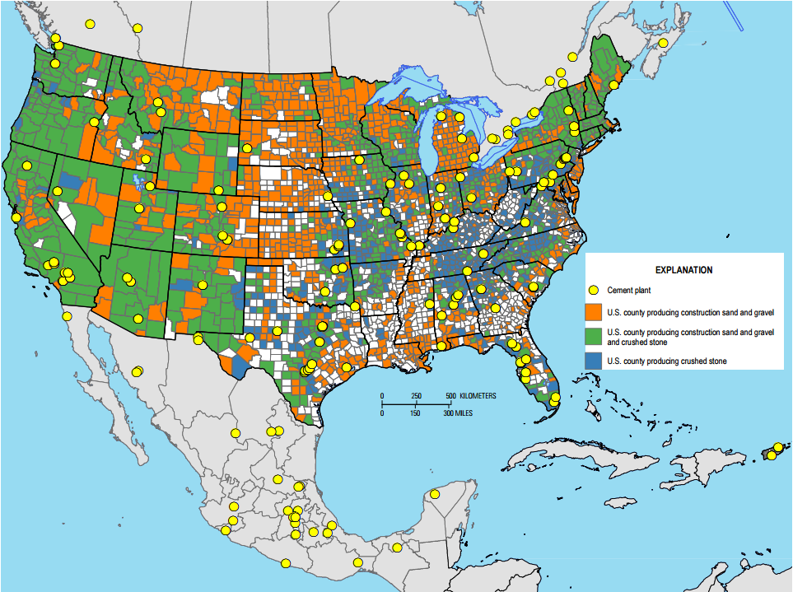
Figure 3. Map showing the location of cement plants and counties producing construction sand and gravel and crushed stone. Data from the USGS.

Other materials

Asphalt substitutes for hydraulic cement in many road applications. However, the USGS does not collect data on its production and consumption. Other mineral materials important for road construction but utilized in much smaller quantities include aluminum, clays, gypsum, lime, magnesium compounds, manganese, nickel, and tungsten. Some of these materials are used as additives in concrete and for soil stabilization. Others may be used as alloying agents in the steel used for reinforced concrete. Data on the production and consumption of these materials are collected by the USGS.

Topographic and Geological Mapping and Geophysical Surveys

Construction requires a knowledge of the topography of the area in which the activity will occur. The USGS has mapped the nation’s topography for over a century and is leading an interagency effort to collect modern, highly accurate topographic data through its 3D Elevation Program (3DEP). This program coordinates the collection of elevation data with far more detail than previously available. These elevation data and resulting topographic maps are necessary to ensure smart, cost effective construction.
Geological maps are the primary source of information about the location of materials needed for infrastructure construction. Although geologic maps have been produced since the founding of the USGS in 1879, many recent USGS geological maps are produced in conjunction with state geological surveys through the National Cooperative Geologic Mapping Program (NCGMP) that supports cooperative agreements with State Geological Surveys. State mapping priorities are defined by State Advisory Committees that represent a broad spectrum of State interests.
In 2016-2017, the USGS is funding geologic mapping projects in 45 States, 29 of which involve mapping for industrial mineral exploration.
Many of the geologic mapping projects are focused on aggregate resource to support land-use development and infrastructure projects. Specifically:
- Work in central Texas involves the geologic mapping and collection of related map data focused on industrial/hydraulic-fracturing sand and construction sand and is addressing the demand for sand resources in the relatively nearby Eagle Ford Shale play in South Texas and the Barnett Shale play in North Central Texas, as well as other shale plays throughout the State. Detailed geologic maps aid professionals dealing with the exploration and mining of sand resources, as well as those involved in permitting and regulating mines, by providing basic geologic information on the location of, variations within, and detailed descriptions of sand-rich areas and surrounding geologic units.

- Work in Virginia is focused on the I-81 Corridor where there are active mine and quarry operations in the twelve counties along the Interstate. These businesses produce large amounts of crushed stone, clay, sand, gravel, dimension stone, and industrial minerals, including iron oxides, high-calcium limestone, salt, and silica. The identification of additional aggregate and high-calcium resources through geologic mapping in this region will support continued economic development.

- Geologic mapping in Arizona is aiding the exploration of river gravels, dominated by highly resistant quartz-rich clasts, and sand in the Colorado River Valley. Both the river gravels and sand are of exceptional quality for many industrial uses and the geologic mapping is providing the basis for aggregate exploration in this region.

Consequences of a Lack of Geologic Data

Lack of geologic data can have consequences for construction projects. For example, the Millennium Tower in San Francisco cost $350 million to construct in 2009. Media reports indicate that tilting and settling of the building could cost millions to hundreds of millions of dollars to fix the problem.

In another example, better geological understanding of the subsurface geology in Austin, Texas through more detailed geological mapping and geophysical surveys could have alleviated some of the construction delays and cost overruns in the construction of tunnels in the MoPac Boulevard project.

The U.S. Geological Survey appreciates the committee’s interest in this topic and is available as a resource to the Committee.

"Denver International Airport Construction and Operating Costs". University of Colorado at Boulder Government Publications Library. July 5, 1997. Accessed March 14, 2017 at https://web.archive.org/web/20080312034239/http://www.colorado.edu/libraries/govpubs/dia.htm ² D.H., Jr., ed., 2002, Planning for the conservation and development of infrastructure resources in urban areas – Colorado Front Range Urban Corridor: USGS Circular 1219. http://geology.cr.usgs.gov/pub/circulars/c1219/
USGS Mineral Commodity Summaries (2017)
The states with geologic mapping projects related to industrial mineral exploration are: Alabama, Arizona, California, Colorado, Idaho, Illinois, Indiana, Michigan, Nevada, Iowa, Kansas, Kentucky, Louisiana, Minnesota, Missouri, Mississippi, North Carolina, Ohio, Oklahoma, Oregon, South Carolina, Tennessee, Texas, Utah, Vermont, Virginia, Washington, West Virginia, and Wisconsin.
https://www.bloomberg.com/news/articles/2017-02-01/who-will-pay-for-san-francisco-s-tilting-sinking-millennium-tower
http://www.mystatesman.com/news/local/slow-road-mopac-tolls-look-what-went-wrong-delayed-project/hGqIAlaovPj0oxcCYuDfjO/

