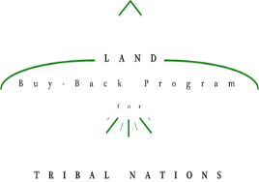

Must receive Tribal approval to use crest/seal. If not approved use Buy-Back logo.

**<Insert Tribal Crest/Seal>**

**Save the Date: <Date of Event>**

**Invitation to <Tribe Name> Land Buy-Back Program <Kickoff> Event**

On behalf of <Tribe Name> of the < Reservation Name>, you are invited to our <kickoff> event. We are hosting this event not only as an informational session to landowners on our reservation, but also as an opportunity for tribal members in neighboring communities to learn more about the Buy-Back Program. Please join us on <Date of Event> at <Location of Event>. Doors open at <Time the Doors will open>. Below you can find the agenda and a list of services that will be available at the event.

*<Event Agenda>*

*<Services provided at event – For example: Landowners will have the opportunity to discuss their interests, receive reports detailing their land and any income derived from leasing, and update their IIM account information. And/or: Notary services will be provided at the event. (Note: Services may vary depending on staffing at event)>*

For more information, contact us at <Insert Contact Phone Number> or <Insert Contact Email Address>.

**If you cannot make the event, you can call the Trust Beneficiary Call Center at 1-888-678-6836 with any questions.**