Interior’s Office of Policy Analysis Seminar
The Private Sector: Engaging for Impact

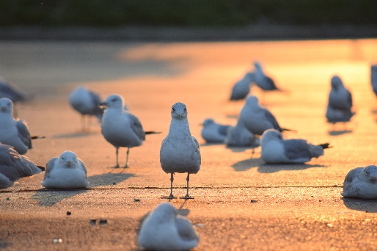
Ring-billed gulls at General Motors Global Propulsion Systems in Pontiac, Michigan

Speaker: Margaret O’Gorman, President, Wildlife Habitat Council
Topic: The Private Sector: Engaging for Impact
Date: June 14, 2021
Time: 12:15-1:15 pm (Eastern)
Webcast Only: Microsoft Teams Live Event (You can also use this link to access the recorded seminar after the event.)

Closed captioning (CC) is available. Click the CC button on the Teams viewer.

Learn how corporate concerns can translate into conservation action. The private sector has compelling reasons for restoring and managing natural resources on lands it owns and manages. Understanding what these drivers are and the challenges and opportunities they represent can help both government agencies and NGOs create sustainable partnerships for positive impact. The speaker will discuss how risk management and community engagement with nature-based action, beyond philanthropy, can translate into conservation action.

To view the Live Event, please click on the link above. Join 5-10 minutes early to avoid technical difficulties.

To view the recorded event, click on the link above (following the event).
The public is welcome to join the Microsoft Live (or recorded) Teams Event.
Interior Department employees seeking training credits: This seminar meets one hour of Executive Education training. To document your attendance, preregister via DOI Talent. Be sure to return to DOI Talent to mark yourself following the seminar.
For additional information about this event, please contact Malka Pattison: malka_pattison@ios.doi.gov

