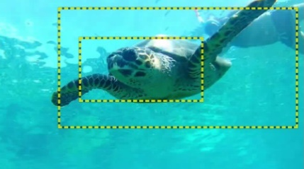
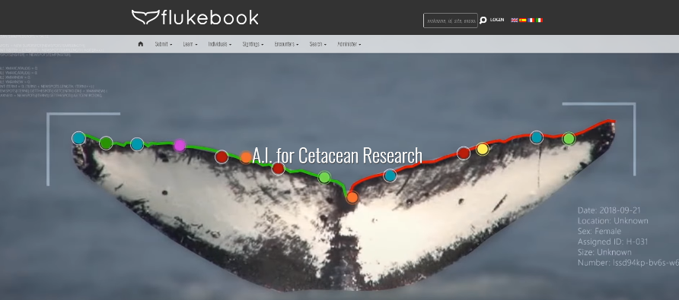
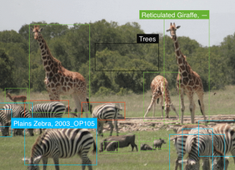
Speakers:
Jacob Levenson, Marine Biologist, Division of Environmental Studies, Bureau of Ocean Energy Management.
Jason Holmberg, Executive Director, Wild Me (wildme.org)
Topic: Artificial Intelligence Is Improving Endangered Species Monitoring in a Changing Climate
Date: Monday, March 8, 2021
Time: 12:15pm – 1:15pm (Eastern)
Webcast ONLY: Microsoft Teams Live Event (You can also use this link to access the recorded seminar after the event.)
Closed captioning (CC) is available by clicking the CC button on the viewer.
From whales to sea turtles, artificial intelligence (AI) is improving our ability to understand animal movements and populations, particularly for endangered species, which may interact with offshore energy and mineral resource extraction activities. At the Department of Interior, the Bureau of Ocean Energy Management (BOEM) is using AI to cost effectively process more data than ever and to improve how that information is used for monitoring endangered species populations. The speakers will describe AI research efforts and discuss their applicability to other areas of wildlife conservation and climate monitoring within the Federal Government.
To view the Live Event, please click on the link above. Join 5-10 minutes early to avoid technical difficulties.
To View the recorded event, click on the link above (following the event).
The public is welcome to join the Microsoft Live (or recorded) Teams Event.
For Interior Department Registrants Seeking Training Credits: This seminar meets one hour of Executive Education training. To document your attendance, preregister via DOI Talent. Be sure to return to DOI Talent to mark yourself complete following the seminar.
For additional information about this event, please contact Malka Pattison

