Interior’s Office of Policy Analysis Seminar
DOI’s Strategic Hazard Identification and Risk Assessment Project

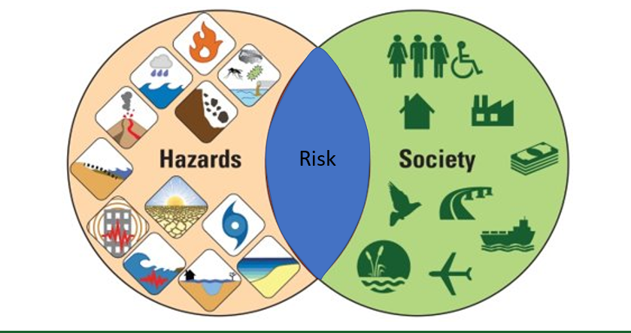
Risk Research and Applications: The intersection of hazards and societal assets

Speakers: Nathan Wood – Research Geographer, Western Geographic Science Center, USGS
Alice Pennaz – Program Analyst, Natural Hazards Mission Area, USGS
Topic: Assessing natural, technological, and adversarial risks to the Department of the Interior
Date: December 13, 2021
Time: 12:15-1:15 pm (Eastern)
Place: Rachel Carson Room (Basement Cafeteria of the Main Interior Building, 1849 C St., NW, Washington, DC 20240)
Webcast ONLY: Microsoft Teams Live Event (You can also use this link to access the recorded seminar after the event.)

Closed Captioning (CC) is available by clicking the CC button on the viewer.

The U.S. Geological Survey is collaborating with the Office of Emergency Management on the Strategic Hazard Identification and Risk Assessment Project (SHIRA) to develop products and tools to help DOI managers better understand the risks to their lands, people, facilities, infrastructure, natural and cultural resources. The interdisciplinary SHIRA team has worked with unit, regional, and national-level managers to determine data and product needs to enable effective risk planning; identified realistic Departmental threats and commonalities between those threats to enable multi-hazard planning; curated and delivered the best available hazard and asset data for the Department; provided approaches to characterize and communicate hazard exposure of DOI assets; developed tools to support DOI risk planning; and built a community of practice to share best practices and leverage limited Departmental resources. This talk will discuss the team's approaches, findings, products, and next steps.

To view the live event, please click on the link above. please join 5-10 minutes early to avoid technical difficulties.

The public is welcome to join the Microsoft Live (or recorded) Teams Event.

Interior Department employees seeking training credits: This seminar meets one hour of Executive Education training. To document your attendance, preregistration via DOI Talent is required. Be sure to return to DOI Talent to mark yourself complete following the seminar.

For additional information about this event, please contact Malka Pattison

